A TDG Executive Vignette

RING OF FIRE
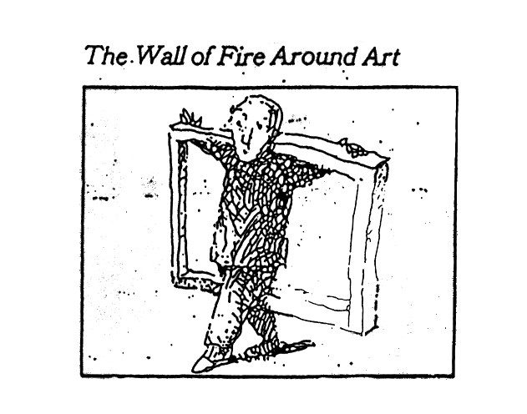

An excerpt from the Wall Street Journal
Anthony Burgess believes that high performance today has been made too easy. In his collection of essays and reviews, "But Do Blondes Prefer Gentlemen?" (McGraw-Hill), he argues for more emphasis on craft, form and hard work.

We need some Johnsonian or Ruskinian pundit to frighten everybody with near impossible conditions for true creativity. We have to stop thinking that what kindergarten children produce with pencil or watercolor is anything more than charming or quaint. If you want to be considered a poet, you'll have to show mastery of the Petrarchan sonnet form or the sestina. Your musical efforts must begin with well-formed fugues. There is no substitute for craft.
fundamental
ideas

There, I think, you may have the nub of the matter. Art or high performance begins with craft, and there is no art until craft has been mastered. You can't create unless you're willing to subordinate the creative impulse to the constriction of a form. But the learning of a craft takes time, and we all think we're entitled to short cuts ...........
Consistent high performance is rare, and sacred, and hard work, and there ought to be a wall of fire around it.

11-25-11
THE DOOLEY GROUP
-40-

